SAFETY DATA SHEET

PRIMA QUICK PRIME

1. Chemical Product and Company Identification
Product Name: PRIMA QUICK PRIME,
Universal, No-Rinse, Multi-Purpose Dual Cure Adhesive, Universal Bond Linker
Manufacturer: B.J.M. Laboratories Ltd.
Address: 12 Hassadna Street, Industrial Park, Or-Yehuda, 6022011, Israel.
Telephone: +972-74-7000111/ Fax: 972-3-7353020.

2. Composition / Information of Hazardous Ingredients
Hazardous Ingredients | CAS# | Hazard Identification & Risk Phrases
2-Hydroxyethylmethacrylate (HEMA) | 868-77-9 | Xi, H319/315-317
Methacrylated phosphoric acid esters | 32435-46-4 | Xi, H319/315-317
4-Methacryloxyethyltrimellitic anhydride | 70293-55-9 | Xn; H302-319/315-317
Acetone | 67-64-1 | H225, Xi, H302/319/EUH066/336
Ethyl alcohol | 64-17-5 | H225, H302

- Additional information: For the wording of the listed risk phrases refer to section 16.

3. Hazards Identification. Xi: Irritant ; H: Flammable .
Acute Health Hazards: May cause eye, respiratory and skin irritation in high concentrations.
Signs and Symptoms of Exposure: High concentrations can cause eye and respiratory irritation. Prolonged skin exposure can cause dryness.
Primary Routes of Exposure: Inhalation, skin contact, eye contact.
Carcinogenicity: NTP – no, OSHA – no, IARC – no.

4. First Aid Measures in Cause of Inhalation
If irritation occurs, take victim to open air.
In case of skin or eye contact flush with large quantities of water for 15 minutes.

5. Fire-Fighting Measures
Flash Point: 18°C (64ºF Ethanol)
Extinguishing Media: Water spray, dry chemical.
Unusial Fire and Explosion Hazards: None.

6. Accidental Release Measures
Clean-Up Procedure: Clean spill area with detergent and water.

7. Handling and Storage
Handling: No special measures necessary if handled according to instructions.
Storage: Keep container tightly closed when not in use.

8. Exposure Controls/ Personal Protection
Respiratory Protection: Avoid inhalation of vapors. No special protection
under normal use vapors.
Hand and Skin Protection: Avoid unnecessary skin contact.

9. Physical and Chemical Properties
Appearance: Transparent liquid
Odour: Weak, ester like odour
Boling Point: N/A
Flash Point: 18°C (64ºF Ethanol)
Solubility in Water: Soluble
Vapor Density (Air = 1): N/E
Vapor Pressure (mmHg): N/E

10. Stability and Reactivity
Stability: This material is stable.
Hazardous Reactions: None if handled according to directions
Hazardous Polymerization: None.
Conditions to Avoid: Heat.
Incompatibility: Reducing agents

11. Toxicological Information

Irritation of Skin: Dryness and Irritation possible upon prolonged exposure.
Allergic Effects: Methacrylate sensitive individuals may exhibit an allergic
reaction.

12. Ecological Information
Do not discharge into suvers or water supplies.
Environmental persistence and degradability: No data available.
Ecotoxicity: No data available.

- Disposal Considerations
May be disposed of in landfill or incinerator In accordance with local, state
and federal regulations.

- Transport Information
14.1 Transport at land | ADR | 3 | RID | 3
 | UN Number | 1170 | Kemler Number | ---
 | Packing Group | III
 | Proper shipping name | Ethanol Solution
14.2 Transport at sea | ADNR | 3 | IMDG | 3
 | UN Number | 1170
 | EMS | F-E, S-D | MFAG
 | Packing Group | III
 | Proper shipping name | Ethanol Solution
14.3 Air transport | ICAO / IATA-DGR | ---
 | UN Number | 1170
 | Proper shipping name | Ethanol Solution
 | Subsidiary Risk | ---
 | Labels | Ethanol Solution
 | Packing Group | III

U.S. DOT Shipping Name: Ethanol Solution
U.S. DOT Hazard Class: 3
Number: UN1170
U.S. Dot Packing Group: III
Other: Class 3 Flammable Liquids.

- Regulatory Information
This product requires classification according to the criteria of EC.
The product is a medical device according to the Council Directive 93/42/EEC and EU Regulation 2017/745 for Medical Devices.

15.1 UN Number | ---
15.2 National regulations
15.3 EU number
15.4 Hazard symbols | Xi 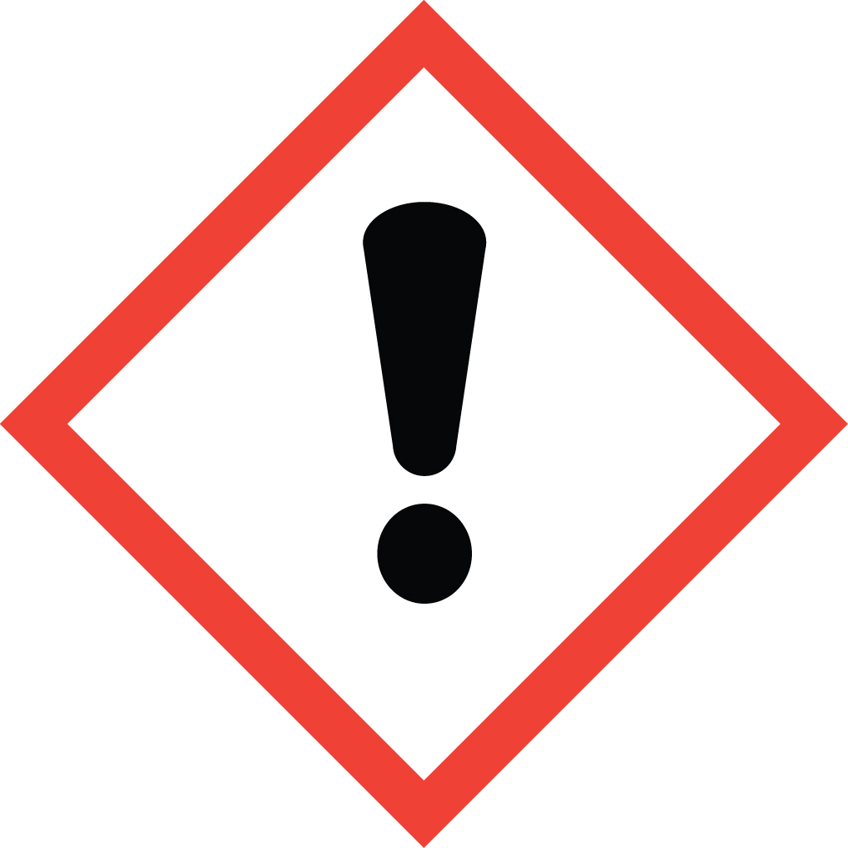, H 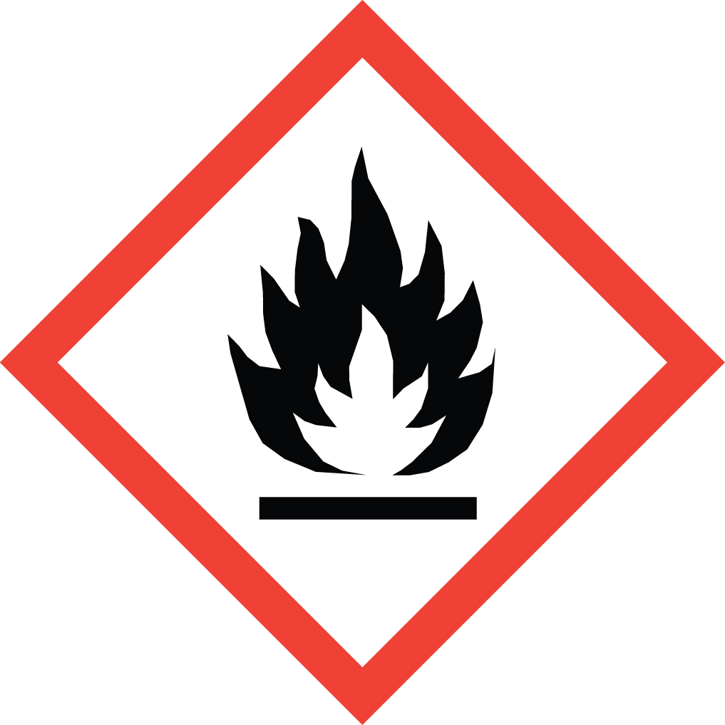
15.5 Hazard designation | Xi: Irritant . H: Flammable . Contains Ethyl Alcohol, HEMA,  4-Methacryloxyethyltrimellitic anhydride, Acetone.
15.6 Risk phrases | R: 225, 302, 319, 335/315, 317, EUH066, 336  225 Highly flammable.  302 Harmful if swallowed.  319 Irritating to eyes.  335/315 Irritating to respiratory system and skin.  317 May cause sensitization by skin contact.  EUH066 Repeated exposure may cause skin dryness or cracking.  336 Vapours may cause drowsiness and dizziness.
15.7 Safety phrases | P: 102, 403, 210, 260, 305+351+338, 303+361+353, 262, 280  102 Keep out of the reach of children.  403 Keep container in a well-ventilated place.  210 Keep away from sources of ignition - No smoking.  260 Do not breathe vapor.  305+351+338 In case of contact with eyes, rinse immediately with plenty of water and seek medical advice.  303+361+353 After contact with skin, wash immediately with plenty of water and soap.  262 Avoid contact with skin and eyes.  280 Wear suitable gloves and eye/face protection.

U.S. – O.S.H.A. Status: This material is Xi: Irritant. F: Flammable under the criteria the U.S. Federal Hazard Communication Standard.

- Other Information

These data are based on our present knowledge. However, they shall not constitute a guarantee for any specific product features and shall establish a legally valid contractual relationship.

Relevant H-phrases

225 Highly flammable.
302 Harmful if swallowed.
319 Irritating to eyes.
335/315 Irritating to respiratory system and skin.
317 May cause sensitisation by skin contact.
EUH066 Repeated exposure may cause skin dryness or cracking.
336 Vapours may cause drowsiness and dizziness.

Xn Harmful.

Material should be maintained in original containers. Empty containers should not be re-used.

AN SI / NFPA 704 DATA
Fire = 3
Health = 1
Reactivity = 1 Specific

This information is based on data considered accurate. However, no warranty is expressed or implied regarding the accuracy of these data, or the results to be obtained from use thereof. In no event will the manufacturer or distributor be responsible for damages of any nature whatsoever resulting from the use of, or reliance upon this information. General properties described herein are to be regarded as guides and are not guaranteed for all samples.

