SAFETY DATA SHEET

Porcelain Silane

- Chemical Product and Company Identification

Product Name: Porcelain Silane Single component silane
Manufacturer: B.J.M. Laboratories Ltd.
Address: 12 Hassadna Street, Industrial Park, Or-Yehuda, 6022011, Israel.
Telephone: +972-74-7000111 / Fax: +972-3-7353020

- Composition / Information of Hazardous Ingredients

Hazardous Ingredients | CAS# | Hazard Identification & Risk Phrases
Ethyl alcohol | 64-17-5 | F, H225
Stabilizer | 2530-83-8 | Xi, H319-315

- Hazards Identification Xi Irritant ; Flammable .
Acute Health Hazards: May cause eye, respiratory and skin irritation.
Chronic Health Hazards: Material is not known to cause significant health problems.
Signs and Symptoms of Exposure: High concentrations can cause eye and respiratory irritation. Prolonged skin exposure can cause dryness.
Primary Routes of Exposure: Inhalation, skin contact, eye contact.
Carcinogenicity: NTP – no, OSHA – no, IARC – no.

- First Aid Measures in Cause of Inhalation
Inhalation: If irritation occurs, take victim to open air. Get medical attention.
In case of skin contact: wash with soap and water.
In case of eye contact: Flush with large quantities of water for 15 minutes. Consult a physician.
In case of ingestion: Drink two glasses of water or milk. Seek medical
attention if a substantial amount has been ingested. Do not induce vomiting.

- Fire-Fighting Measures
Flash Point: 18°C / 64ºF (Ethanol)
Extinguishing Media: Carbon dioxide, foam or dry chemical.
Unusual Fire and Explosion Hazards: Upon combustion, irritating gases may form.

- Accidental Release Measures
Personal Precautions: Prevent skin/ eye contact
Environmental Precautions: Avoid ground water contamination.
Clean-Up Procedure: Wipe with damp paper towel. Discard properly.

- Handling and Storage
Handling: No special measures necessary if handled according to instructions.
Storage: Keep container tightly closed when not in use. Keep about 10ºC. Keep material in original packaging. Avoid extreme heat and light.

- Exposure Controls/ Personal Protection
Exposure Controls: Use only in well ventilated areas.
Eye Protection: Use protective eyewear.
Hand and Skin Protection: Avoid unnecessary skin contact. Wear latex gloves when handling.
Hygiene Measures: Remove spilled material from skin and clothing. Do not eat or drink when handling this material.

- Physical and Chemical Properties
Appearance: Colorless liquid
Odor: Odorless.
Boling Point/ Range: N/E
Evaporation Bate (water = 1): N/A
Vapor Density (Air = 1): N/A
Solubility in Water: Miscible
Solubility in organic solvents: Soluble in alcohols, ketones, etc.

- Stability and Reactivity
Stability: This material is stable.
Hazardous Reactions: None if handled according to directions.
Conditions to Avoid: Heat.
Incompatibility: Strong caustics, metals, sulfides and sulfites.

- Toxicological Information
Acute oral toxicity: LD50 (rat) > 5000 mg/kg
Irritation to Eyes: Irritates the eyes.
Irritation of Skin: May irritate the skin.
Allergic Effects: May cause allergic reaction on contact with skin.
Other: If swallowed, may cause sore throat and burns of the mouth and throat. Prolonged exposure may cause burns to the respiratory tract, contact with soft tissues may cause burns.

- Ecological Information
There is no specific information on the product. Use according to good working practices, avoiding release of the product into environment.

- Disposal Considerations
May be disposed of in landfill or incinerator In accordance with local, state and federal regulations.

- Transport Information

14.1 Transport at land | ADR | 3 | RID | 3
 | UN Number | 1170 | Kemler Number | ---
 | Packing Group | III
 | Proper shipping name | Ethanol Solution
14.2 Transport at sea | ADNR | 3 | IMDG | 3
 | UN Number | 1170
 | EMS | F-E, S-D | MFAG
 | Packing Group | III
 | Proper shipping name | Ethanol Solution
14.3 Air transport | ICAO / IATA-DGR | ---
 | UN Number | 1170
 | Proper shipping name | Ethanol Solution
 | Subsidiary Risk | ---
 | Labels | Ethanol Solution
 | Packing Group | III

U.S. DOT Shipping Name: Ethanol Solution
U.S. DOT Hazard Class: 3
Number: UN1170
U.S. Dot Packing Group: III
Other: Class 3 Flammable Liquids.

- Regulatory Information

This product requires classification according to the criteria of EC.
The product is a medical device according to the Council Directive 93/42/EEC and EU Regulation 2017/745 for Medical Devices.

15.1 UN Number | 1170
15.2 National regulations
15.3 EU number
15.4 Hazard symbols | W, Xi, 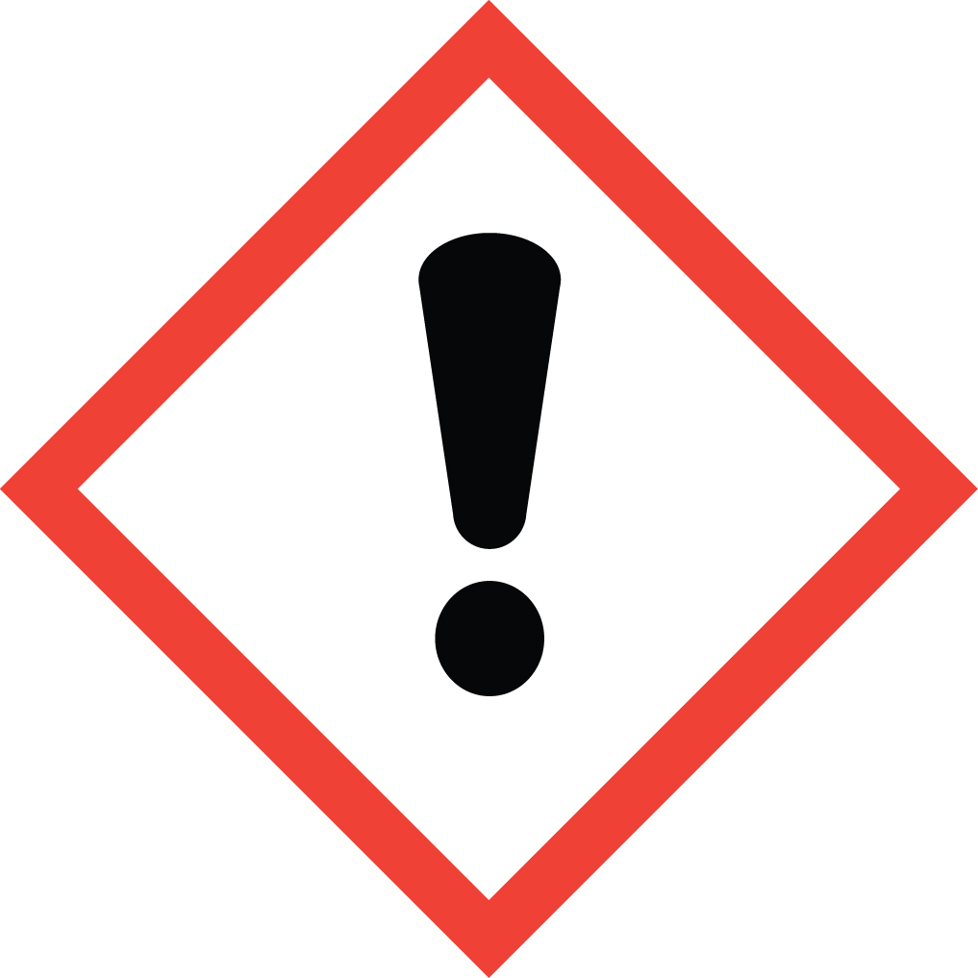 H 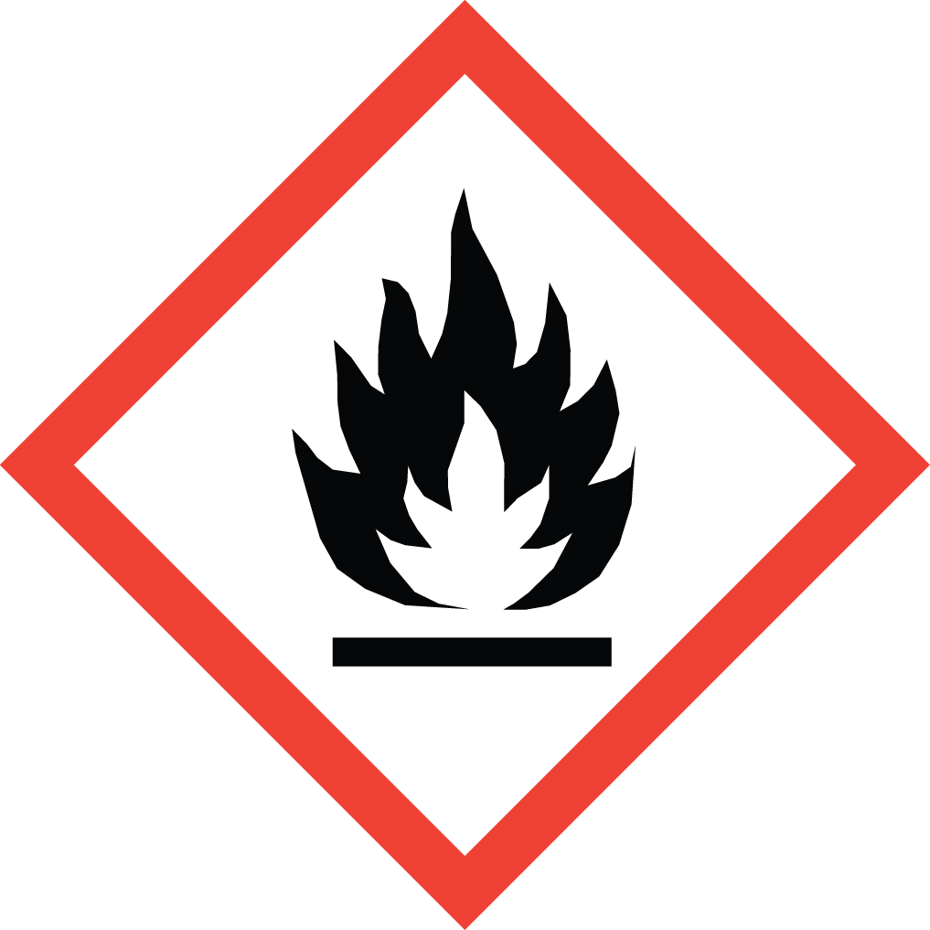
15.5 Hazard designation | W: Warning. Xi: Irritant. H: Highly Flammable. Contains Ethyl Alcohol
15.6 Risk phrases | R: 225, 379, 335/315  225 Highly flammable.  319 Irritating to eyes.  335/315 Irritating to respiratory system and skin.
15.7 Safety phrases | SP: 102, 403, 210, 260, 305+351+338, 303+361+353, 262, 280  102 Keep out of the reach of children.  403 Keep container in a well-ventilated place.  210 Keep away from sources of ignition - No smoking.  260 Do not breathe vapor.  305+351+338 In case of contact with eyes, rinse immediately with plenty of water and seek medical advice.  303+361+353 After contact with skin, wash immediately with plenty of water and soap.  262 Avoid contact with skin and eyes.  280 Wear suitable gloves and eye/face protection. .

U.S. – O.S.H.A. Status: This material is Xi: Irritant. F: Flammable under the criteria the U.S. Federal Hazard Communication Standard.

- Other Information

These data are based on our present knowledge. However, they shall not constitute a guarantee for any specific product features and shall establish a legally valid contractual relationship.

Relevant H-phrases

11 Highly flammable.
36 Irritating to eyes.
37/38 Irritating to respiratory system and skin.

Xi Irritant.

Material should be maintained in original containers. Empty containers should not be re-used.

ANSI / NFPA 704 DATA
Fire = 3
Health = 1
Reactivity = 1 Specific

This information is based on data considered accurate. However, no warranty is expressed or implied regarding the accuracy of these data, or the results to be obtained from use thereof. In no event will the manufacturer or distributor be responsible for damages of any nature whatsoever resulting from the use of, or reliance upon this information. General properties described herein are to be regarded as guides and are not guaranteed for all samples.

