Safety Data Sheet
High-Q-Bond ™ Adhesive Resin Cement, Base

Form 70010/B-MSDS, Rev. 5
Last revised: 18-Sep-2022
Approved for use: 24-Jan-2023
---------------------------------------------------------------------------------------------------------------------------
1. Chemical product and company identification
Product Name: High-Q-Bond™ Adhesive Resin Cement, Base

Manufacturer:
B.J.M Laboratories Ltd.®
12 Hassadna St. Industrial Park
Or-Yehuda 6022011
Israel
Tel: +972-3-7353000; Fax: +972-3-7353020

2. Composition / Information on Ingredients

Hazardous Ingredients | CAS # |  | Hazard Identification & Risk Phrases
2-Hydroxyethylmethacrylate | 868-77-9 |  | Xi, H319/315-317
Triethyleneglycoldimethacrylate | 109-16-0 |  | Xi, H319/335/315, H317
Co-initiator | 10287-53-3 |  | Xi, H319/335/315
Photoinitiators | 10373-78-1 |  | Xi, H319/335/315
Treated Fumed Silica |  | 67762-90-7 |  | N/E

- Additional information: For the wording of the listed risk phrases refer to section 16.

3. Hazards Identification
Acute Health Hazards: May cause eye, respiratory and skin irritation in high concentrations.
Chronic Health Hazards: Material is not known to cause significant health problems.
Signs and Symptoms of Exposure: High concentrations can cause eye and respiratory irritation. Prolonged skin exposure can cause dryness.
Primary routes of exposure: inhalation, skin contact, eye contact
Carcinogenicity: NTP – no, OSHA – no, IARC – no.

4. First Aid Measures
In case of inhalation: If irritation occurs, take victim to open air. If breathing difficulty persists, consult a physician.
In case of skin contact: Wash with soap and water.
In case of eye contact: Flush with large quantities of water for 15 minutes. Consult a physician.
In case of ingestion: Consult a physician.

5. Fire-Fighting Measures
Flash Point: N/E
Extinguishing Media: Carbon dioxide, water spray, dry chemical
Special Fire Fighting Procedures: Avoid a direct jet of water.
Unusual Fire and Explosion Hazards: None

6. Accidental Release Measures
Environmental Precautions: Avoid seepage into sewers and water supplies.
Clean-Up Procedure: Contain spill and pick up material with a suitable absorbent material. Place absorbent into a container for later disposal. Clean spill area with detergent and water.

7. Handling and Storage
Handling: No special measures necessary if handled according to instructions.
Storage: Keep container tightly closed when not in use. Store in a cool, dry location. Keep material in original packaging.

8. Exposure Controls / Personal Protection
Exposure Controls: Use only in well-ventilated areas.
Respiratory Protection: Avoid inhalation of vapors. No special protection under normal use.
Hand and Skin Protection: Avoid unnecessary skin contact. Wear latex gloves when handling.
Eye Protection: Wear safety goggles or safety glasses with side shields when handling.
Hygiene Measures: Remove spilled material from skin and clothing. Do not eat or drink when handling this material.
9. Physical and Chemical Properties
Appearance: Yellow paste
Odor: Specific odor
Boiling Point/Range: N/A
Evaporation Rate (Water = 1): N/A
Vapor Density (Air = 1): N/A
Solubility in Water: Insoluble

10. Stability and Reactivity
Stability: This material is stable.
Hazardous Reactions: None if handled according to directions
Hazardous Polymerization: May occur.
Conditions to Avoid: Heat, UV light and contamination.
Incompatibility: Free radicals, reducing agents, heavy metal ions
Hazardous Decomposition Products: Carbon dioxide, water, carbon monoxide, acrylic decomposition products, depending on conditions of heating and burning.

11. Toxicological Information
Acute oral toxicity : LD₅₀ (rat) > 5000mg/KG
Irritation of Skin: dryness and irritation possible upon prolonged exposure
Allergic Effects: Methacrylate sensitive individuals may exhibit an allergic reaction.

12. Ecological Information
Do not discharge into sewers or water supplies
Environmental persistence and degradability: no data available
Ecotoxicity: no data available

13. Disposal Considerations:
May be disposed of in landfill or incinerator in accordance with local, state and federal regulations.

14. Transport Information:
14.1 Transport at land | ADR |  | RID
 | UN Number |  | Kemler Number
 | Packing Group
 | Proper shipping name
14.2 Transport at sea | ADNR |  | IMDG
 | UN Number
 | EMS |  | MFAG
 | Packing Group
 | Proper shipping name
14.3 Air transport | ICAO / IATA-DGR
 | UN Number
 | Proper shipping name
 | Subsidiary Risk
 | Labels
 | Packing Group

U.S. DOT Shipping Name: Not Regulated
U.S. DOT Hazard Class: None
U.N./N.A. Number: None
U.S. DOT Packing Group: None
Other: Not considered hazardous cargo

15. Regulatory Information:
This product requires classification according to the criteria of EC.
The product is a medical device according to the Council Directive 93/42/EEC and EU Regulation 2017/745 for Medical Devices.

15.1 UN Number
15.2 National regulations
15.3 EU number
15.4 Hazard symbols | Xi, 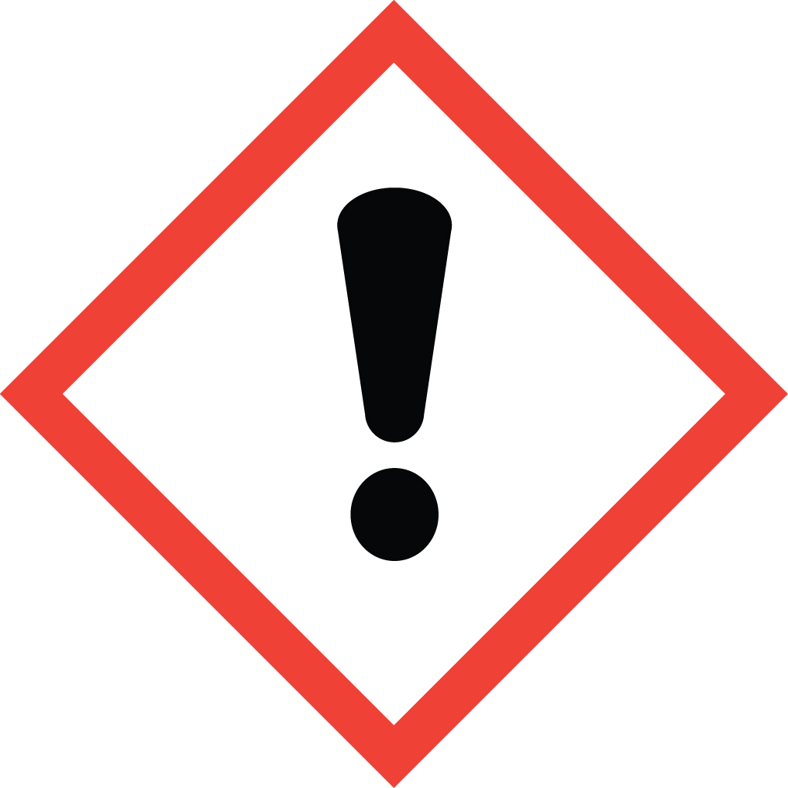
15.5 Hazard designation | Xi: Irritant.
15.6 Risk phrases | H: 319, 335/315, 317  319 Irritating to eyes.  335/315 Irritating to respiratory system and skin.  317 May cause sensitization by skin contact.
15.7 Safety phrases | P: 102, 403, 210, 260, 305+351+338, 303+361+353, 262, 280  102 Keep out of the reach of children.  403 Keep container in a well-ventilated place.  210 Keep away from sources of ignition - No smoking.  260 Do not breathe vapor.  305+351+338 In case of contact with eyes, rinse immediately with plenty of water and seek medical advice.  303+361+353 After contact with skin, wash immediately with plenty of water and soap.  262 Avoid contact with skin and eyes.  280 Wear suitable gloves and eye/face protection.

U.S.-O.S.H.A. Status: This material is not hazardous under the criteria of the U.S. Federal Hazard Communication Standard.

16. Other Information

These data are based on our present knowledge. However, they shall not constitute a guarantee for any specific product features and shall establish a legally valid contractual relationship.

Relevant R-phrases

319/335/315 Irritating to eyes, respiratory system and skin.

Xi Irritant .

Material should be maintained in original containers. Empty containers should not be re-used.

ANSI/NFPA 704 Data:
Fire = 1
Health = 0
Reactivity = 0
Specific Hazard = None

This information is based on data considered accurate. However, no warranty is expressed or implied regarding the accuracy of these data, or the results to be obtained from use thereof. In no event will the manufacturer or distributor be responsible for damages of any nature whatsoever resulting from the use of, or reliance upon this information. General properties described herein are to be regarded as guides and are not guaranteed for all samples.

