SAFETY DATA SHEET

HIGH-Q-BOND RETAINER

1. Chemical Product and Company Identification

Product Name: High-Q-Bond Light Cure Lingual Retainer

Manufacturer: B.J.M. Laboratories Ltd.
Address: 12 Hassadna Street, Industrial Park, Or-Yehuda, 6022011, Israel.
Telephone: +972-74-7000111/ Fax. 972-3-7353020.

2. Composition / Information of Hazardous Ingredients

Hazardous Ingredients | CAS # | Hazard Identification & Risk Phrases
Urethane Diacrilate Oligomer | 72869-86-4 | Xi, H319/335/315
Polymerization accelerators | 60506-81-2 | N/E
Triethylenglycoldimethacrylate | 109-16-0 | Xi, H319/335/315, H317
2-Hydroxyethylmethacrylate | 868-77-9 | Xi, H319/315-317
Photoinitiators | 10373-78-1 | N/E
Photoinitiators | 10287-53-3 | Xi, H319/335/315
Fumed Silica | 112945-52-5 | H319/335/315

- Additional information: For the wording of the listed risk phrases refer to section 16.

3. Hazards Identification Xi Irritant 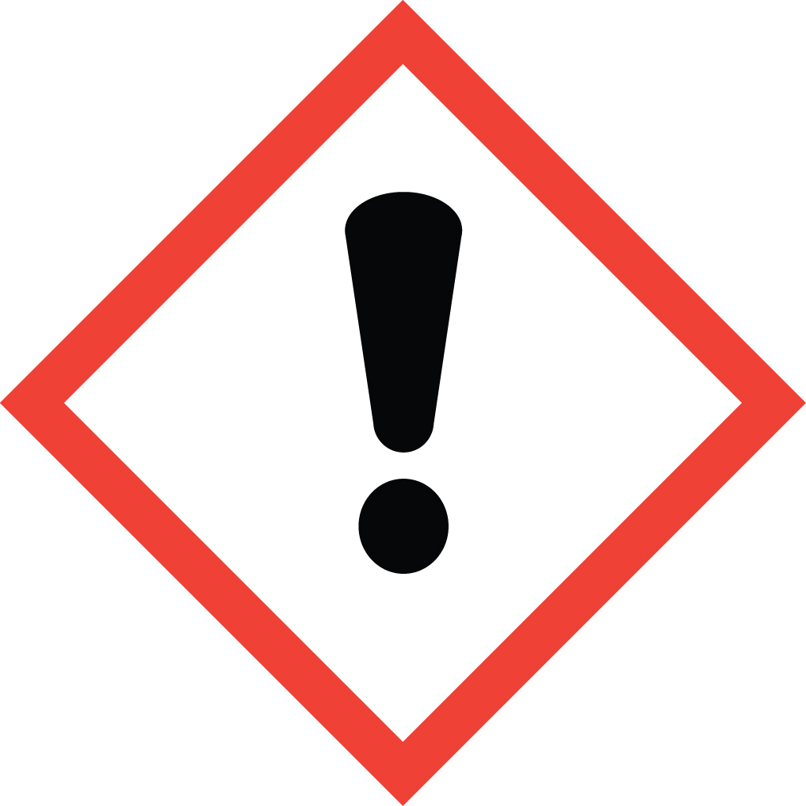

Acute Health Hazards: May cause eye, respiratory and skin irritation.
Chronic Health Hazards: Material is not known to cause significant health problems.
Signs and Symptoms of Exposure: High concentrations can cause eye and respiratory irritation. Prolonged skin exposure can cause dryness.
Primary Routes of Exposure: Inhalation, skin contact, eye contact.
Carcinogenicity: NTP – no, OSHA – no, IARC – no.

4. First Aid Measures in Cause of Inhalation

If irritation occurs, take victim to open air.
In case of skin contact: wash with soap and water.
In case of eye contact: Flush with large quantities of water for 15 minutes.
Consult a physician.
In case of ingestion: Consult a physician.

5. Fire-Fighting Measures

Flash Point: N/E
Extinguishing Media: Carbon dioxide, water spray, dry chemical.
Special Fire Fighting Procedures: Avoid a direct jet of water.
Unusial Fire and Explosion Hazards: None.

6. Accidental Release Measures

Environmental Precautions: Avoid seepage into sewers and water supplies.
Clean-Up Procedure: Contain spill and pick up material with a suitable
absorbent material. Place absorbent into a container for later disposal. Clean
spill area with detergent and water.

7. Handling and Storage

Handling: No special measures necessary if handled according to instructions.
Storage: Keep container tightly closed when not in use. Store in a cool, dry
location, away from light, open flames, contamination. Keep material in
original packaging.

8. Exposure Controls/ Personal Protection

Exposure Controls: Use only in well ventilated areas.
Hand and Skin Protection: Avoid unnecessary skin contact. Wear latex gloves
when handling.
Hygiene Measures: Remove spilled material from skin and clothing. Do not
eat or drink when handling this material.

9. Physical and Chemical Properties

Appearance: Light orange paste.
Odour: Specific odor.
Boling Point/ Range: N/E
Evaporation Rate (water = 1): N/A
Vapor Density (Air = 1): N/A
Solubility in Water: Insoluble

10. Stability and Reactivity

Stability: This material is stable.
Hazardous Reactions: None if handled according to directions
Hazardous Polymerization: May occur.
Conditions to Avoid: Heat; UV-light.
Incompatibility: Free radicals, reducing agents, heavy metal ions.
Hazardous Decomposition Products: Carbon dioxide, carbon monoxide,
acrylic decomposition products, depending on conditions of heating and
burning.

11. Toxicological Information

Acute oral toxicity: LD50 (rat) > 5000 mg/kg

Irritation of Skin: Dryness and Irritation possible upon prolonged exposure.
Allergic Effects: Methacrylate sensitive individuals may exhibit an allergic
reaction.

12. Ecological Information

Do not discharge into suvers or water supplies.
Environmental persistence and degradability: No data available.
Ecotoxicity: No data available.

- Disposal Considerations

May be disposed of in landfill or incinerator In accordance with local, state
and federal regulations.

- Transport Information

14.1 Transport at land | ADR |  | RID
 | UN Number |  | Kemler Number
 | Packing Group
 | Proper shipping name
14.2 Transport at sea | ADNR |  | IMDG
 | UN Number
 | EMS |  | MFAG
 | Packing Group
 | Proper shipping name
14.3 Air transport | ICAO / IATA-DGR
 | UN Number
 | Proper shipping name
 | Subsidiary Risk
 | Labels
 | Packing Group

U.S. DOT Shipping Name: Not Regulated
U.S. DOT Hazard Class: None U.N/ N.A.
Number: None
U.S. Dot Packing Group: None
Other: Not considered hazardous cargo.

- Regulatory Information

This product requires classification according to the criteria of EC.
The product is a medical device according to the Council Directive 93/42/EEC and EU Regulation 2017/745 for Medical Devices.

15.1 UN Number
15.2 National regulations
15.3 EU number
15.4 Hazard symbols | Xi,
15.5 Hazard designation
Xi: Irritant.
15.6 Risk phrases | H: 302, 319, 335/315, 317  302 Harmful if swallowed  319 Irritating to eyes.  335/315 Irritating to respiratory system and skin.  317 May cause sensitization by skin contact.
15.7 Safety phrases | P: 102, 403, 210, 260, 305+351+338, 303+361+353, 262, 280  102 Keep out of the reach of children.  403 Keep container in a well-ventilated place.  210 Keep away from sources of ignition - No smoking.  260 Do not breathe vapor.  305+351+338 In case of contact with eyes, rinse immediately with plenty of water and seek medical advice.  303+361+353 After contact with skin, wash immediately with plenty of water and soap.  262 Avoid contact with skin and eyes.  280 Wear suitable gloves and eye/face protection. .

U.S. – O.S.H.A. Status: This material is not hazardous under the criteria of the U.S. Federal Hazard Communication Standard.

- Other Information

These data are based on our present knowledge. However, they shall not constitute a guarantee for any specific product features and shall establish a legally valid contractual relationship.

Relevant H-phrases

319/335/315 Irritating to eyes, respiratory system and skin.
317 May cause sensitization by skin contact.

Xi Irritant .

Material should be maintained in original containers. Empty containers should not be re-used.

ANSI/NFPA 704 Data:
Fire = 1
Health = 0
Reactivity = 0
Specific Hazard = None

This information is based on data considered accurate. However, no warranty is expressed or implied regarding the accuracy of these data, or the results to be obtained from use thereof. In no event will the manufacturer or distributor be responsible for damages of any nature whatsoever resulting from the use of, or reliance upon this information. General properties described herein are to be regarded as guides and are not guaranteed for all samples.

