SAFETY DATA SHEET
BJM Root Canal Sealer

- Chemical Product and Company Identification

Product Name: BJM Root Canal Sealer, Paste Amine
Manufacturer: B.J.M. Laboratories Ltd.
Address: 12 Hassadna St., Industrial Park, Or-Yehuda 6022011, Israel.
Telephone: +972-74-7000111 / Fax. +972-3-7353020

- Composition / Information of Hazardous Ingredients

Hazardous Ingredients | CAS# | Hazard Identification & Risk Phrases
Poly(oxyethylene, oxypropylene)diamine | 65605-36-9 | H319/315
Zirconium Oxide | 1314-23-4 | Xi, H319/335/315
Fumed Silica | 112926-00-8 | H319/335/315
Silane quaternary ammonium salt | 199111-50-7 | N/E

- Additional information: For the wording of the listed risk phrases refer to section 16.

- Hazards Identification
Acute Health Hazards: May cause eye, respiratory and skin irritation.
Chronic Health Hazards: Material is not known to cause significant health problems.
Signs and Symptoms of Exposure: High concentrations can cause eye and respiratory irritation. Prolonged skin exposure can cause dryness.
Primary Routes of Exposure: Inhalation, skin contact, eye contact.
Carcinogenicity: NTP – no, OSHA – no, IARC – no.

- First Aid Measures in Cause of Inhalation
If irritation occurs, take victim to open air.
In case of skin contact: wash with soap and water.
In case of eye contact: Flush with large quantities of water for 15 minutes.
Consult a physician.
In case of ingestion: Consult a physician.

- Fire-Fighting Measures
Flashpoint: N/A
Extinguishing Media: Carbon dioxide, water spray, foam or dry chemical.
Special Fire Fighting Procedures: Avoid a direct jet of water.
Unusual Fire and Explosion Hazards: None.

- Accidental Release Measures
Environmental Precautions: Avoid spillage into sewers and water supplies.
Clean-Up Procedure: Contain spill and pick up material with a suitable
absorbent material. Place absorbent into a container for later disposal. Clean
spill area with detergent and water.

- Handling and Storage
Handling: No special measures necessary if handled according to instructions.
Storage: Keep container tightly closed when not in use. Store in a cool, dry
location. Keep material in original packaging.

- Exposure Controls/ Personal Protection
Exposure Controls: Use only in well ventilated areas.
Hand and Skin Protection: Avoid unnecessary skin contact. Wear latex gloves
when handling.
Hygiene Measures: Remove spilled material from skin and clothing. Do not
eat or drink when handling this material.

- Physical and Chemical Properties
Appearance: White paste.
Odor: Specific odor.
Boling Point/ Range: N/A
Evaporation Bate (water = 1): N/A
Vapor Density (Air = 1): N/A
Solubility in Water: Insoluble

- Stability and Reactivity
Stability: This material is stable.
Hazardous Reactions: None if handled according to directions
Hazardous Polymerization: May occur.
Conditions to Avoid: Heat; UV-light.
Incompatibility: Free radicals, reducing agents, heavy metal ions.
Hazardous Decomposition Products: Carbon dioxide, carbon monoxide,
acrylic decomposition products, depending on conditions of heating and
burning.

- Toxicological Information

Acute oral toxicity:

Irritation of Skin: Dryness and Irritation possible upon prolonged exposure.

Allergic Effects: Individuals may exhibit an allergic reaction.

- Ecological Information
Do not discharge into suvers or water supplies.
Environmental persistence and degradability: No data available.
Ecotoxicity: Water hazard class 1 (German Regulation) (Self-assessment): slightly hazardous for water.
Do not allow product to reach ground water, water course or sewage system, even in small quantities.

- Disposal Considerations
May be disposed of in landfill or incinerator In accordance with local, state and federal regulations.

- Transport Information

14.1 Transport at land | ADR |  | RID
 | UN Number |  | Kemler Number
 | Packing Group
 | Proper shipping name
14.2 Transport at sea | ADNR |  | IMDG
 | UN Number
 | EMS |  | MFAG
 | Packing Group
 | Proper shipping name
14.3 Air transport | ICAO / IATA-DGR
 | UN Number
 | Proper shipping name
 | Subsidiary Risk
 | Labels
 | Packing Group

U.S. DOT Shipping Name: Not Regulated
U.S. DOT Hazard Class: None U.N/ N.A.
Number: None
U.S. Dot Packing Group: None
Other: Not considered hazardous cargo.

- Regulatory Information
This product requires classification according to the criteria of EC.
The product is a medical device according to the Council Directive 93/42/EEC and EU Regulation 2017/745 for Medical Devices.

15.1 UN Number | -
15.2 National regulations
15.3 EU number
15.4 Hazard symbols | Xi, 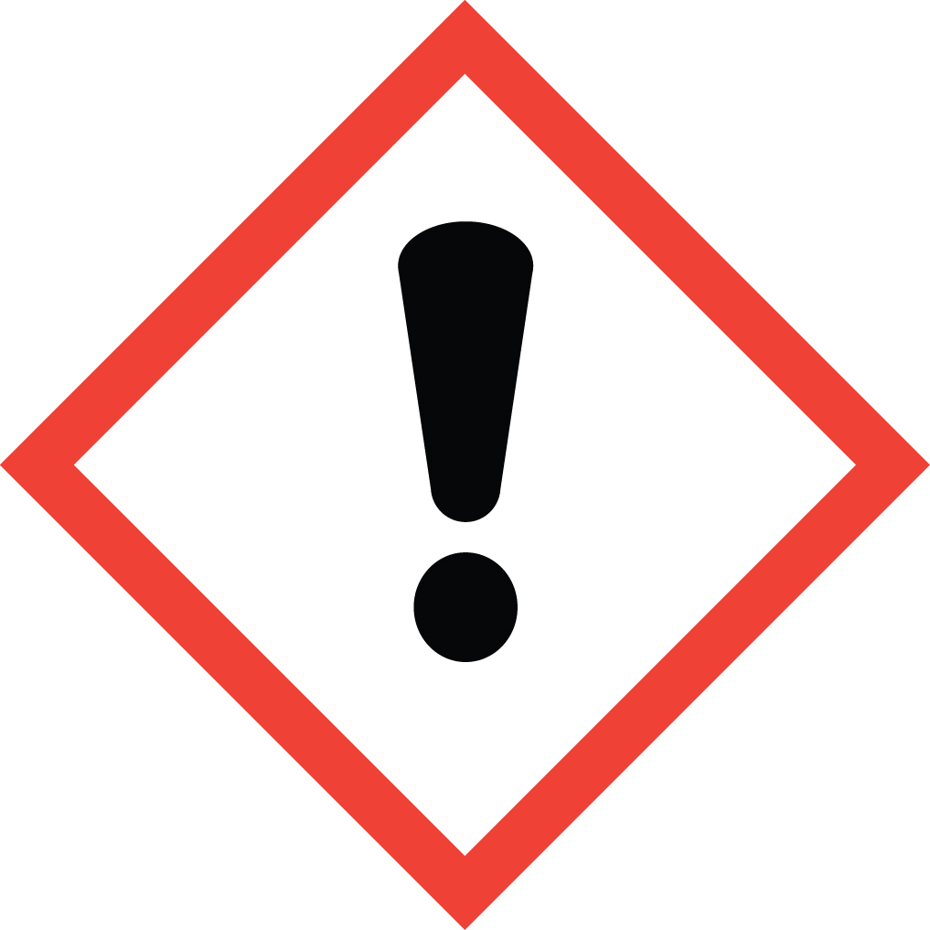
15.5 Hazard designation | Xi: Irritant.
15.6 Risk phrases | H: 319,335/315  319 Irritating to eyes.  335/315 Irritating to respiratory system and skin.
15.7 Safety phrases | P: 102, 403, 210, 260, 305+351+338, 303+361+353, 262, 280  102 Keep out of the reach of children.  403 Keep container in a well-ventilated place.  210 Keep away from sources of ignition - No smoking.  260 Do not breathe vapor.  305+351+338 In case of contact with eyes, rinse immediately with plenty of water and seek medical advice.  303+361+353 After contact with skin, wash immediately with plenty of water and soap.  262 Avoid contact with skin and eyes.26 In case of contact with eyes, rinse immediately with  plenty of water and seek medical advise.  28 After contact with skin, wash immediately with  plenty of water and soap.  262 Avoid contact with skin and eyes.  280 Wear suitable gloves and eye/face protection.

U.S. – O.S.H.A. Status: This material is not hazardous under the criteria of
the U.S. Federal Hazard Communication Standard.

- Other Information

These data are based on our present knowledge. However, they shall not constitute a guarantee for any specific product features and shall establish a legally valid contractual relationship.

Relevant H-phrases

319 Irritating to eyes.
335/315 Irritating to respiratory system and skin.
Xi – IRRITAT.

Material should be maintained in original containers. Empty containers should not be re-used.

ANSI / NFPA 704 DATA
Fire = 1
Health = 1
Reactivity = 1 Specific

This information is based on data considered accurate. However, no warranty is expressed or implied regarding the accuracy of these data, or the results to be obtained from use thereof. In no event will the manufacturer or distributor be responsible for damages of any nature whatsoever resulting from the use of, or reliance upon this information. General properties described herein are to be regarded as guides and are not guaranteed for all samples.

