SAFETY DATA SHEET:

AUTO-CURE ACTIVATOR

1. Chemical Product and Company Identification

Product Name: Auto-Cure Activator

Chemical activator for use with Prima 2000 and Prima Quick Bond

Manufacturer: B.J.M. Laboratories Ltd.
Address: 12 Hassadna Street, Industrial Park, Or-Yehuda, 6022011, Israel.
Telephone: +972-74-7000111/ Fax: +972-3-7353020.

- Composition / Information of Hazardous Ingredients

Hazardous Ingredients | CAS# | Hazard Identification & Risk Phrases
Acetone | 67-64-1 | H225, Xi,  H225/H319/EUH066/H336
Benzoyl peroxide | 94-36-0 | Explosive, Xi, H319, H317
Ethyl alcohol | 64-17-5 | H317, H225

- Additional information: For the wording of the listed risk phrases refer to section 16.

3. Hazards Identification. Xi Irritant 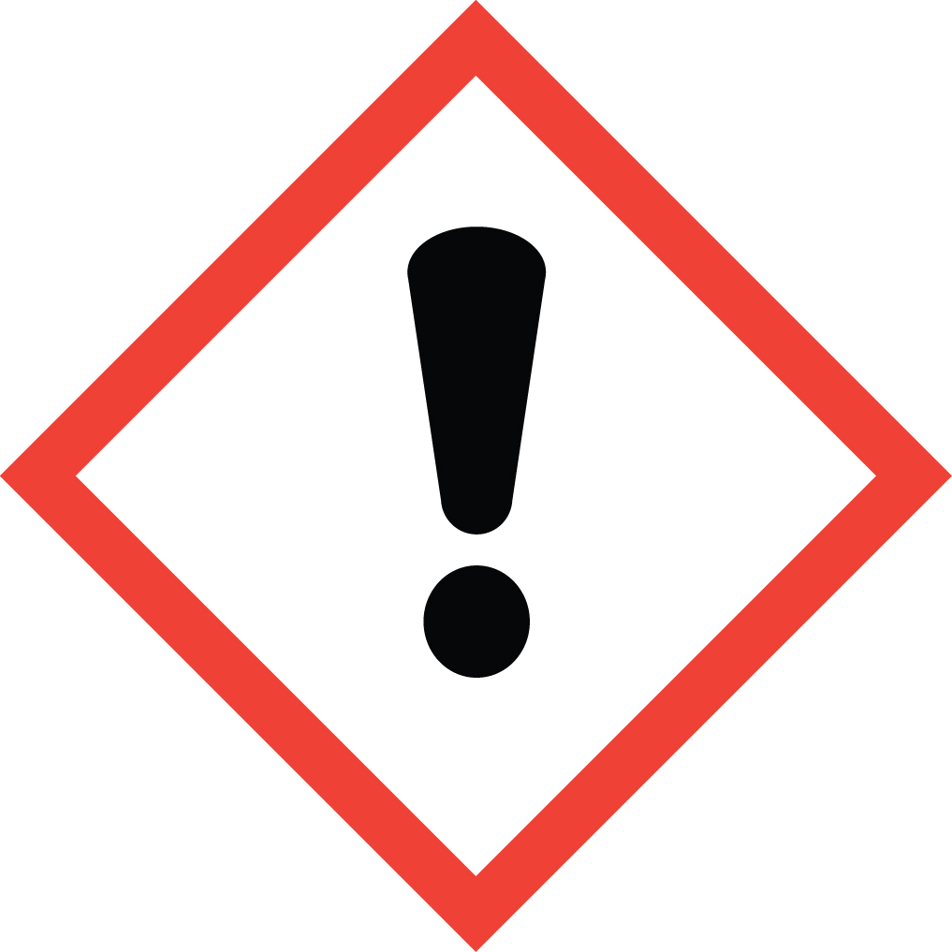; Flammable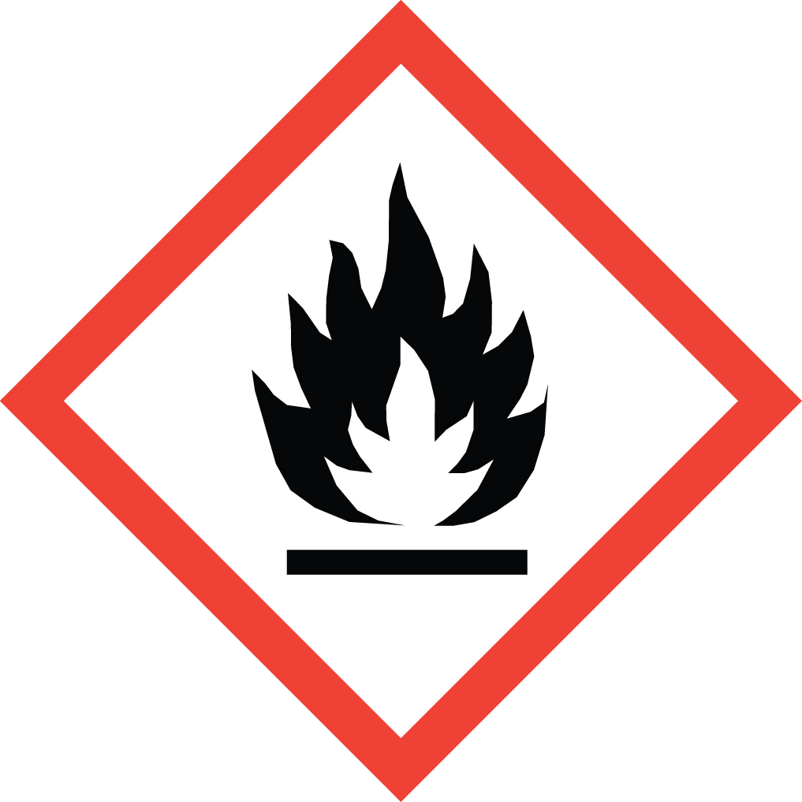.

Acute Health Hazards: May cause eye, respiratory and skin irritation in high concentrations.
Signs and Symptoms of Exposure: High concentrations can cause eye and respiratory irritation. Prolonged skin exposure can cause dryness.
Primary Routes of Exposure: Inhalation, skin contact, eye contact.
Carcinogenicity: NTP – no, OSHA – no, IARC – no.

4. First Aid Measures in Cause of Inhalation

If irritation occurs, take victim to open air. Get medical attention if
discomfort persists.
In case of skin contact wash thoroughly with soap and water.
In case of eyes contact flush with water for 15 minutes including under
eyelids.

5. Fire-Fighting Measures

Flash Point: N/E
Extinguishing Media: chemical foam, carbon dioxide or dry chemical.
Unusual Fire and Explosion Hazards: Heat can cause rapid release of energy.

6. Accidental Release Measures

Clean-Up Procedure: Absorb spills with inert material – keep spilled material
out of sewers.

7. Handling and Storage

Handling: No special measures necessary if handled according to instructions.
Storage: Avoid extreme heat. Keep in temperature of below 24ºC in tightly
closed container when not in use, away from heat, light and ignition sources.
Packing materials: opaque, polyethylene lined drums.

8. Exposure Controls/ Personal Protection

Respiratory Protection: Avoid inhalation of vapors. No special protection
under normal use vapors.
Hand and Skin Protection: Avoid unnecessary skin contact.

9. Physical and Chemical Properties

Appearance: Colourless liquid
Odour: Specific odour
Boling Point: N/A
Solubility in Water: Miscible
Solubility in Organic Solvents: Soluble
Vapor Density(Air = 1): N/E
Vapor Pressure (mmHg): N/E

10. Stability and Reactivity

Stability: This material is stable.
Hazardous Reactions: None if handled according to directions.
Hazardous Decomposition Products: Oxides of carbon.
Hazardous Polymerization: None.
Conditions to Avoid: Heat, light, aging and contaminations.
Incompatibility: Reducing and oxidizing agents
peroxides and amines.

11. Toxicological Information

Skin: Dryness and Irritation possible upon prolonged exposure.
Eyes: May cause irritation and damage if not removed promptly.
Inhalation: Prolonged or excessive inhalation may cause respiratory tract irritation.
Ingestion: Uncured material may be harmful or fatal if swallowed.

12. Ecological Information

Do not discharge into savers or water supplies.
Environmental persistence and degradability: No data available.
Ecotoxicity: No data available.

- Disposal Considerations

May be disposed of in landfill or incinerator In accordance with local, state
and federal regulations.

- Transport Information

14.1 Transport at land | ADR | 3 | RID | 3
 | UN Number | 1090 | Kemler Number | ---
 | Packing Group | II
 | Proper shipping name | Flammable Liquid (Acetone, Ethyl Alchohol)
14.2 Transport at sea | ADNR | 3 | IMDG | 31-02
 | UN Number | 1090
 | EMS | F-E, S-D | MFAG | 300
 | Packing Group | II
 | Proper shipping name | Flammable Liquid (Acetone, Ethyl Alchohol)
14.3 Air transport | ICAO / IATA-DGR | ---
 | UN Number | 1090
 | Proper shipping name | Flammable Liquid (Acetone, Ethyl Alchohol)
 | Subsidiary Risk | ---
 | Labels | Flammable Liquid (Acetone, Ethyl Alchohol)
 | Packing Group | II

U.S. DOT Shipping Name: Aceton / Ethanol Solution
U.S. DOT Hazard Class: 2
Number: UN1090
U.S. Dot Packing Group: II
Other: Class 2 Flammable Liquids.

- Regulatory Information

This product requires classification according to the criteria of EC.
The product is a medical device according to the Council Directive 93/42/EEC and EU Regulation 2017/745 for Medical Devices.

15.1 UN Number | 1090
15.2 National regulations
15.3 EU number
15.4 Hazard symbols | Xi , F
15.5 Hazard designation | Xi: Irritant. H225: Higly Flammable. Contains Benzoyl Peroxide, Acetone, Ethyl Alcohol.
15.6 Risk phrases | H: 225, 319, 317, EUH066, 336  225 - Highly flammable.  319 - Irritating to eyes.  317 - May cause sensitization by skin contact.  EUH066 - Repeated exposure may cause skin dryness or cracking.  336 - Vapours may cause drowsiness and dizziness.
15.7 Safety phrases | P: 102, 403+235, 210, 260, 302+351+338, 262, 280, 303+361+353  P102 - Keep out of reach of children.  P403 + P235 - Store in a well-ventilated place. Keep cool.  P210 - Keep away from heat, hot surfaces, sparks, open flames and other ignition sources. No smoking.  P260 - Do not breathe dust/fume/gas/mist/vapours/ spray.  P305 + P351 + P338 - IF IN EYES: Rinse cautiously with water for several minutes. Remove contact lenses, if present and easy to do. Continue rinsing.  P303 + P361 + P353 - IF ON SKIN (or hair): Take off immediately all contaminated clothing. Rinse skin with water [or shower].  P262 - Do not get in eyes, on skin, or on clothing.  P280 - Wear protective gloves/protective clothing/eye protection/face protection/hearing protection/….

U.S. – O.S.H.A. Status: This material is Xi: Irritant. H225: Flammable under the criteria the U.S. Federal Hazard Communication Standard.

- Other Information

These data are based on our present knowledge. However, they shall not constitute a guarantee for any specific product features and shall establish a legally valid contractual relationship.

Relevant H-phrases:
240+241 Risk of explosion by shock, friction, fire or other sources of ignition.
270 May cause fire.
EUH 209/ 209A Highly flammable.
319 Irritating to eyes.
315 May cause sensitization by skin contact.
EUH 066 Repeated exposure may cause skin dryness or cracking.
336 Vapors may cause drowsiness and dizziness.

Material should be maintained in original containers. Empty containers should not be re-used.

AN SI / NFPA 704 DATA
Fire = 3
Health = 1
Reactivity = 1 Specific

This information is based on data considered accurate. However, no warranty is expressed or implied regarding the accuracy of these data, or the results to be obtained from use thereof. In no event will the manufacturer or distributor be responsible for damages of any nature whatsoever resulting from the use of, or reliance upon this information. General properties described herein are to be regarded as guides and are not guaranteed for all samples.

